LESSON TITLE: Integrative Lesson on the Great Failure of Great Leaders
LESSON #: 3 out of a 5-day Thematic Unit on Leadership
Teacher Name: Emily E. Meyers
Date: March 18th, 2015

Preparation and Planning
ESL Course: General English: Upper Intermediate Level
The Common European Framework of Reference: B2:3 Level
Topic / Theme: Leadership
Length of Lesson: Two eighty-minute lessons back-to-back with a ten-minute break in between
Lesson Size: 18 Students
Objectives:
Listening: Students will be able to listen to their peers’ explanations and ask a follow up question appropriate to the context and material throughout the index card activity as well as the gallery walk. Students will be able to identify interesting and applicable words and phrases from listening to Steve Jobs’ 2005 Stamford Commencement speech. Students will be able to listen to class discussion and provide feedback to their peers as well as add their own thoughts and opinions. The transcript of the speech can be found in Appendix 1.
Speaking: Students will be able to use vocabulary appropriate to the context and material to explain various answers throughout the class. Students will be able to ask thought provoking questions in relation to the material at hand. Students will be able to discuss the speech. Students will be able to discuss and deepen their understanding of leadership through the use of words, phrases, quotes, and pictures. The vocabulary list can be found in Appendix 2.
Reading: Students will be able to read vocabulary that their peers select.
Students will be able to read words and phrases from the listening. Students will be able to read through many different quotes on leadership and pick one that appeals to them. Students will be able to read a handout describing famous failures and select information important and interesting to them. The “Famous Failures” handout can be found in Appendix 3.
Writing: Students will be able to write a vocabulary word they associate with the listening in a timed situation. Students will be able to take notes on a handout by recording words and phrases that they find to be interesting from the speech. Students will be able to accurately write down quotes that they find online. Students will be able to write their own discussion questions as a reflection on a Famous Failures Handout. The Note Taking Handout can be found in Appendix 4.
Bridging
Background Knowledge: Students will already have completed four eighty-minute lessons on leadership, famous world leaders, and qualities leaders share. The students would have already read an article about six famous world leaders, listened to a radio interview about qualities leaders share, and made personal connections with the text by asking students to share their journal entries where they wrote about a person who they consider to be a leader. The students will be encouraged to utilize the vocabulary words previously introduced in this thematic unit. They will also be asked to relate the information they find in the listening as well as in the handout to the famous leaders they have already learned about.
Linking: I will provide the opportunity for whole-class discussions, small-group discussions, as well as pair discussions. These discussions will serve as platforms to create connections between the material and the students. I will review the unit vocabulary at the beginning of the class. Connections will be explicitly stated during whole class discussions and encourage implicit connections through small group discussions. While discussing the “Famous Failures” handout, I will ask students to find the similarities and differences between the leaders listed on the handout and the leaders the book used as examples throughout the reading.
Engagement with New Material
Active Learning Engagement: Students will be asked to watch the speech as homework prior to class. Students will be consistently asked to reflect on their choice of material (words, phrases, quotes). Students will be asked for their own thoughts and opinions and have the opportunity to share those in a variety of settings. Students will be engaged in the material through the use of many different mediums (index cards, whiteboard, projector, posters, handout)
Ensure Engagement: I will model each stage of the lesson to support students’ clear understanding of each task. I will ask students for their individual reflections on the speech.
I will ask students to write down the words and phrases they found interesting from the speech.
I will ask students to support their decisions in choosing their material through verbal explanation. I will ask students to pick a leadership quote they find particularly interesting and present it to the class.
Application & Assessment
Warm Up: I will take attendance by calling out the students’ names and asking them to give the class an example of someone who they consider to be a leader. After I have completed the attendance, the class will engage in a “popcorn” activity where will be asked by their peers to recall the leader that another peer had mentioned. For example, if Laura popcorned Fahad then she would ask him to recall the name of leader that Siwon had mentioned. Then Fahad would popcorn another student and so on. This would continue until all the students had been called on. I will refer to my Informal Assessment Checklist to keep track of students’ speaking and overall comprehension skills. The Informal Assessment Checklist can be found in Appendix 5.
Opening Activity: I will transition into the opening activity by asking the students what they thought about Steve Jobs’ Stamford Commencement speech that they were assigned to listen to for homework. After a brief discussion, I will hand each student a blank index card. I will explain that the students will have one minute to write down a word that they think describes the speech well. I will continue with the directions by saying after everyone has written a word on their index card, they will hold the index card up to their forehead facing outward so their peers can read the word they wrote. I will explain that the students will then take turns asking each other why they chose that particular word. I will model this activity with one student for the class to see to provide the necessary scaffolding because this is a new activity. I will ask the students to explain to a partner how the activity will work. I will then set the timer for one minute and the students will complete the activity. I will assess the students informally for this activity by judging the relevance of the words they chose and the accuracy of the descriptions they use to explain the words. This will be noted on the Informal Assessment Checklist.
Note Taking: I will transition into this activity by explaining that while the students just chose one word to describe the speech, it is also important to be able to produce accurate notes on the speech as well. I will explain that the next activity will have to do with note taking and I will ask the students if they have ever had experience with note taking before. After a brief discussion I will give students a Note Taking Handout and ask them to review it before the class begins the next activity. I will explain that we will be listening to a small segment of the speech they listed to for homework and they will take notes on the words and phrases they find to be interesting or noteworthy. They will then be asked to write these on the board for the whole class to see. I will model this activity for the students and then ask three of the students to explain to the class what we are doing. The class will then begin the activity. I will assess students on this activity by collecting their Note Taking Handouts and reviewing them outside of class. I will be looking for spelling, relevance of words and phrases, as well as the amount of notes. Before the activity begins, the students will be told that I will collect the notes to review at the end of class. I will also explain the areas of focus that I will be reviewing so they can pay attention to those as they complete the activity.
Review of the Words and Phrases: I will divide the whiteboard evenly so that each student has his or her own space to write down the words or phrases that they identified. The students will come up to the board and record what they had written down. The class will then have a whole-class discussion and the students will use the “popcorn” method where they will ask each other why they picked the words and phrase that they did. As a class, we will discuss the similarities and differences in the words and phrases the students’ identified. The Informal Assessment Checklist will be used to assessment this activity.
Leadership Quotes: I will transition into the next activity by circling a few quotes that had been written on the board (if there have not been any quotes written on the board I will write one). I will ask the students to converse in pairs about what the difference is between the quote and a word or short phrase. Then, I will ask the students to explain what they were talking about with their partner to the class. I will explain in detail what a quote is and hand out (facedown) a piece of paper to each student. On this piece of paper will be a quote from someone or something that particular student likes. For example, one student of mine loves the Harry Potter books so I will give her a quote from Harry Potter. I will ask the students to turn the quotes over and read them to insure there is a connection between the explicit definition of what a quote is and the real world application of one. I will transition the class back to the topic of Leadership by reading a quote that I had saved on a piece of paper for myself. This quote will be by John Maxwell and it will state, “Leaders become great, not because of their power, but because of their ability to empower others.” I will ask the students to use their phones, or I will provide them with iPads, and look up a leadership quote that appeals to them. Once they have identified a quote, they will be asked to write that quote on their individual posters that will be already taped around the room. After each student writes their quote, the whole class will take turns walking from poster to poster and listening to each student explain why they picked their quote. The students will be encouraged to ask questions to further their understanding of the context, vocabulary, and speaker. The Informal Assessment Checklist will be used to assess this activity.
Famous Failures: I will have chosen a quote of my own and written it on a poster as well. Therefore, the last quote that the class will read will be the one that I chose. This quote will be from Walt Disney. I will transition into the next activity after explaining the quote by asking the students to return to their seats and tell the class what they know about Walt Disney. I will be making a list of facts the students share on the board. After the class has exhausted their knowledge on Walt Disney, I will explain that he struggled before he became famous and was actually considered to be a failure at one point in his life. I will then give the students the Famous Failures Handout and ask them to read it individually. The handout features Walt Disney as well as Steve Jobs. As the students are reading the handout, I will ask them to think about three questions in: 1) what did you already know 2) what surprised you the most and 3) what lessons or words of advice can we take away from this handout? I will also walk around and be available for students to ask questions about the vocabulary or the people mentioned on the handout.
Closing: After the students have finished reading Famous Failures Handout, I will explain that their homework is to create 3-5 discussion questions about the handout. I will ask the students to explain to each other what a discussion question is and then ask one student to tell the class. I will reiterate what a discussion question is and give a few examples. The homework will be written on the board. I will end class by asking a few students to share the lessons or take-aways they identified from the Famous Failures Handout and how they can relate it to the information we had been studying in the previous classes on Leadership.
Technology
Computer: For the Note Taking Activity, I will use my computer and speakers to play Steve Jobs’ Stamford Commencement Speech. My computer and speakers will be in the front of the room close enough to the students so that everyone can here it. There are three different Internet connections associated with the school so the likelihood of Internet troubles is minimal. However, I will also have an extra copy of the transcript in case any technological issues present themselves.
Phones and iPads: For the Leadership Quote Activity I will ask my students to use their own phones to look up quotes. I will have told my students to bring in phones or devices that can connect to the Internet at the end of the last class and sent out a reminder email. However, if students were unable to bring in a device then I will have extra iPads available for them to use. There are three different Internet connections associated with the school so the likelihood of Internet troubles is minimal. However, in case the Internet does have issues, I will bring in many printed quotes about leadership and ask the students to pick one that appeals to them from those.
Reflection
Positives: The warm-up activity provided an energetic start to the class and immediately began holding students accountable for their presence and engagement. It transitioned well into the opening activity, which continued this level of energy and created a relaxed and fun class atmosphere. Due to this being the fifth lesson on the same unit, I wanted to give students the opportunity to connect with the material in a personal way. The students showed enthusiasm and excitement as they held their cards up to their heads and read their peers’ work, engaging in the material as I hoped they would. This activity was student-oriented and it framed the whole lesson in a positive way by giving the students the power and authority over the subject matter. They were laughing, asking each other questions, showing surprise when some students had written down the same word, and gave great explanations as to why they chose the word they did. This same feeling was found during the Review of Words and Phrases Activity when the students were asking each other about the words and phrases they had written on the board from the speech. They made connections with each other as they found similarities between the answers, and showed interest in the words and phrases that were different than others. The students were being very encouraging with one another as they conducted the popcorn approach. Many students made remarks such as: “Great job”, “I never thought of that”, “You are totally right”, and “I completely agree”. I noticed that the element of surprise that the poporn method used kept students alert and engaged in the lesson. Furthermore, the Leadership Quotes Activity highlighted student autonomy by allowing students to use their phones and encouraging them to pick a quote specifically for themselves. They were given their own paper and wrote on it in any way that they saw fit. The students were very engaged in this activity and kept calling me over to confirm that the quote they picked was a “good one”. The quotes the students decided on, and wrote on the whiteboard, were moving. Really, it was not simply the quote itself but the explanation behind each quote that created a sense of seriousness and personal acknowledgement within the lesson. Everyone was proud of their quotes and the students took each other very seriously as each person read the quote and explained why they picked it. There was a feeling of respect toward each person as they presented. Finally, the Famous Failures Worksheet elicited the responses I was looking for as well. Although the students were supposed to read the worksheets individually, many could not help themselves and began discussing their disbelief or surprise with a student next to them. It was nice to have the energy from the beginning of the lesson carry on through to the end. By closing with students’ take-aways and connections with the previous material, I felt a though the class had a definitive end that the next class up nicely.
Unexpected Situations: Although the beginning of the class was off to a great start, the Note Taking Activity ended up defusing the energy and excitement from the class. Although my lesson was supposed to be an integrative General English skills lesson, it ended up mainly focusing on speaking and listening. While this is fine, because we had spent the majority of that week delegating tasks equally to the different skills, it made the Note Taking Task seem out of place. I felt as though it seemed forced and a bit unnatural to transition away from speaking and listening into note taking and then back into speaking and listening. Also, I intended for the note taking worksheet to be funny and interesting but the students did not understand that the cartoon character had hearts over his eyes to symbolize his love for the words and phrases from the speech. They were confused and they started asking questions about the image. This interrupted the class, as I had to stop and explain to them the purpose behind the cartoon. Additionally, although I had positioned this activity as a note taking activity, it did not have any academic note taking structure represented on it. I should have rephrased the purpose behind the activity or simply taken out the words “note taking” from it entirely.
Contingency Plan: When the students began focusing on the cartoon on my worksheet instead of the task at hand, I quickly pulled up the original copy of the worksheet on my computer to show them what the cartoon had looked like in color. I explicitly stated my purpose for designing worksheet the way I did and acknowledged that it did not come out the way I had hoped. This led to the students understanding the meaning behind the cartoon and allowed us to move onto the actual task. When I realized that the task seemed a bit forced and random I tried to take the focus off of the note taking worksheets and onto the students themselves. By redirecting the attention back to the students, the class picked up its original pace and energy level. This made the transition into the leadership quotes seem natural and the students were actively engaged again.
Next Time: When I do this lesson next time, I will not use the note taking worksheet although I will keep the focus of that activity the same. I will ask the students to listen to the speech again but use their own paper to take notes. This will keep the focus on the listening task instead of trying to create a writing task out of the activity as well. The students will feel free to record the words and phrases they identify in any way they want as long as it is legible and they are able to use the information for the rest of the activity. I will also explicitly state in the beginning of the lesson that this will be a lesson with a speaking and listening focus so the students know the purpose of the lesson and why we are not utilizing materials and activities centered around reading and writing. I predict that by giving the students this information in an explicit manner, they are able to ask questions in an allotted time frame instead of spending time answering their questions during activities throughout the lesson. I hope this method will create a smoother lesson that has more focused objectives.
Purpose and Objectives: My students succeeded in meeting the purpose of this lesson in addition to meeting their speaking, listening, reading and writing objectives. The purpose of the lesson was for the students to take a real-world example of leadership (the Steve Jobs’ speech) and be able to incorporate it into their personal English language framework. Through this incorporation, they were to use vocabulary from the unit we had been studying and make connections between the activities in this lesson to the subject matter and activities in previous lessons. I saw that the students were able to meet the purpose of this lesson within many different activities. For example, during the warm-up activity the students were able to reflect on the listening exercise they had for homework and think critically about a relevant and accurate vocabulary word to summarize the speech in. While this act alone does not necessarily prove that the students were meeting the purpose, their descriptions of why they chose the vocabulary word that they did showed me that they were able to create personal connections to the listening activity. Additionally, some students used vocabulary from the material they had been given earlier in the week to describe the speech. This showed me that they were integrating the new information into their vocabulary in a successful way. Another example of how the students succeeded in meeting the purpose of this lesson was the Leadership Quote Activity. Through this activity, the students were able to practically implement the theme of leadership into their own lives by choosing a quote specific to them and presenting it to the class. During the presentation portion of this activity, I observed most of the students utilizing the vocabulary from a previous reading exercise and experimenting with phrasal verbs that they had recently been taught.
Future Needs: Although many of my students enjoyed highly communicative aspects of this lesson, I received feedback from my both my students and my USD peers that my lesson needed a more explicit academic focus. Although I envisioned my lesson being beneficial to my students in a practical way, where they were able to practice their speaking and listening in a non-traditional sense, it seems a though my students need more academic support. One of my peers expressed the sentiment that at the end of his English language classes he “wanted something tangible to take away from it”. What he meant by that was he wanted to walk away from the class knowing he had learned something new, instead of just simply practicing something he already knew how to do (speaking and listening). This was a very humbling realization and made me reflect on my teaching practice. Upon reflection, I noticed that my teaching style favors communicative practices with academic support instead of academic practices with communicative support. I realize that in the future I should make this a more even balance as to accommodate for all of my students’ needs and expectations.
Glows & Grows: After the implementation of this lesson plan, which I was able to do through a simulation lesson at USD as well as in class at EF, I was able to gain ample feedback from my peers, students, and professors. Due to this, I have been able to better assess my teaching practice and the strengths and weaknesses it has. An overarching strength that was recognized in a significant portion of the feedback I received was the creative and interactive nature of my lesson. As an educator, I recognize that the primary function of a lesson should be its ability to incite curiosity and the ability for students to comprehend why it is relevant. Together, those two aspects of lesson planning is a powerful combination. Students want information that is applicable to their lives, and they most of them want it in an entertaining fashion. On the other hand, the delivery of information may not always suit every student’s needs or expectations. In this sense, it is very important to take students’ educational and cultural backgrounds into consideration when planning a lesson. For those students who grew up in a strict educational environment may not enjoy activities where the purpose is not explicitly stated. Through an open dialogue with my students and peers, I have acquired a deeper understanding of the necessity of balance within the classroom and the affect explicitly stating the purpose and objectives has on the willingness of students. Through continued experience, experimentation, and reflection I predict that I will be able to combat these grows and turn them into a beneficial learning experience.
Appendix 1
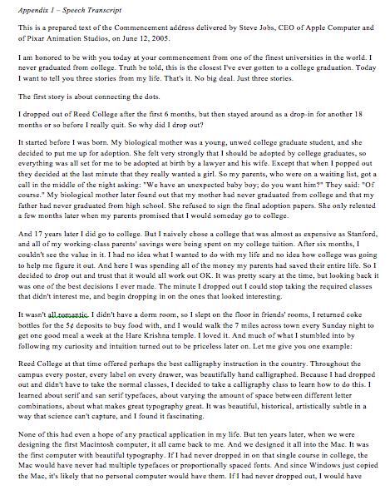

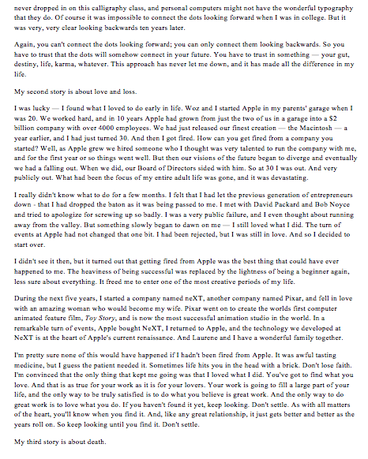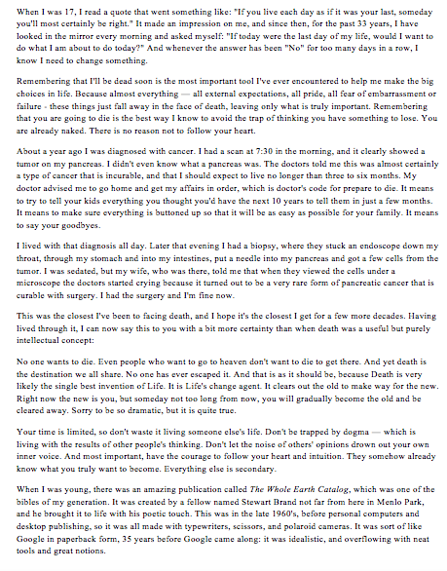
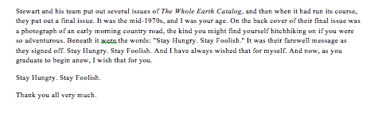

Appendix 2 – Unit Vocabulary 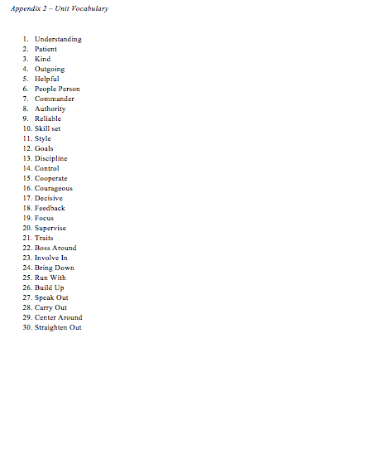

Appendix 3 – Famous Failures Handout

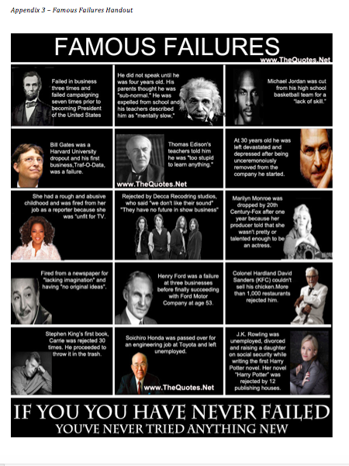
Appendix 4 – Note Taking Worksheet 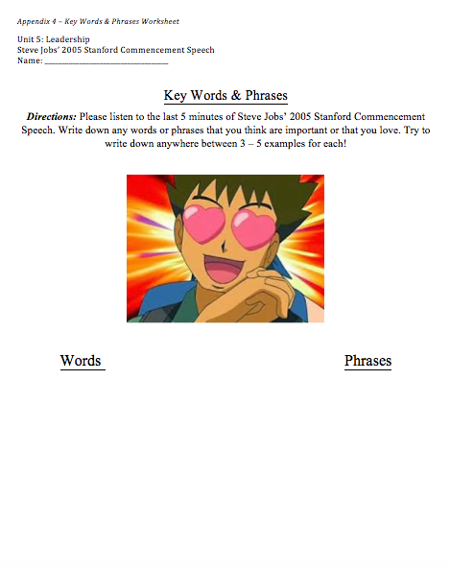

Appendix 5 – Informal Assessment Checklist
