LESSON TITLE: Dealing with Awkward Situations Introductory Lesson
LESSON #: 1 out of a 5-day Thematic Unit on Awkward Situations
Teacher Name: Emily E. Meyers
Date: March 2nd, 2015

Preparation and Planning
ESL Course: General English: Upper Intermediate Level
The Common European Framework of Reference: B2:3 Level
Topic / Theme: Awkward Situations
Length of Lesson: Two eighty-minute lessons back-to-back with a ten-minute break in between
Lesson Size: 18 Students
Objectives:
Listening: The listening task will be for the students to listen to an expert on how to handle awkward situations. The students’ objective will be to listen for specific information and record the necessary information from the listening task on paper. The transcript of this can be found in Appendix 1.
Speaking: The speaking task will be for the students to talk about how to handle awkward situations as well as role-play a variety of awkward situations. The students’ objective will be to implement the applicable vocabulary into conversational English successfully. The role-play scenarios can be found in Appendix 2.
Reading: The reading task will be to read different blog posts about awkward situations. The students’ objectives will be to read for specific information as well as to identify tone and point of view while reading. The blog posts and reading comprehension questions can be found in Appendix 3 and Appendix 4.
Writing: The writing tasks will be to create and reply to letters in an advice column. The students’ objectives are to identify the awkward situation in the advice column, succinctly address the situation, and provide appropriate advice using the unit’s vocabulary. The vocabulary list can be found in Appendix 5.
Bridging
Background Knowledge: The students are familiar with term “awkward situation” and can provide a few examples from their personal lives without previous scaffolding. Although I viewed the topic of this lesson as interesting and fun, I was nervous to see how the students would react considering they come from very difficult cultural backgrounds. I tried to keep this at the forefront of my mind as I conducted the lesson.
Linking: I will open my lesson by asking students to define what the word “awkward” means in pairs. With their definition, I will also ask the students to share an awkward situation they have been a part of, have seen on TV or in movies, or heard about from a friend. After the students create a definition and share examples of an awkward situation with each other, each pair will read their definition of the word “awkward” to the class and (if they feel comfortable) share an awkward situation they just discussed with their partner. After the completion of this warm-up activity, I will ask the students to do a “walkabout”. A walkabout is when I have placed lesson material around the classroom and students must walk around the classroom to engage with it. For this walkabout, I will have printed out ten pieces of paper with examples of awkward situations and taped them around the room. The students will be asked to walk around silently and read each piece of paper. If the students have personally experienced this awkward situation they will be asked to sign their name on the paper. This will get the students out of their seats, expose them to vocabulary that is often associated with awkward situations, and create a personal connection with the topic.
Engagement with New Material
Active Learning Engagement: To engage students in the active learning of the new material I will help them create personal connections to the material through the bridging activities mentioned above and keep reiterating those connections throughout the introduction of the new material. I will also share personal examples of awkward situations I have been a part of, seen on TV or in movies, or heard of from my friends. I also hope that the sense of community that comes from this topic, since it is likely everyone has experienced an awkward situation in their life, encourages active engagement and participation as well.
Ensure Engagement: To ensure that all students are engaged I will consistently do informal assessments through observation and conversation. If students seem off track or distracted I will bring them back to task by asking them to read out loud, provide examples to support the material, and ask their opinions. This will not be done in a way in which the students are negatively singled out. All students will be asked to participate this way, however if they are not paying attention they will be asked to participate immediately. Additionally, I will include individual-work, pair-work, group-work, and whole class-work so all students will have different responsibilities throughout the tasks we do in the lesson. The students will be moving around the class as they switch from individual-work to pair-work to group-work and whole class-work. This rotation of activities and tasks will help fight monotony and boredom.
Application
Listening: Throughout the listening task, the students will be asked to complete eight multiple-choice questions, eight true/false questions, identify the six indirect approaches the speaker suggests for the awkward situations in writing, as well as answer seven fill-in-the-gap questions in a paragraph transcribed from the listening task. Afterward, the students will be asked to relate the listening task to their personal lives by answering discussion questions such as: Have you ever been in an awkward situation like those mentioned on the show? Which pieces of Sally’s advice do you agree with? Which do you disagree with? As well as, suggest some other ways of dealing with the situations discussion on the show.
Speaking: Throughout the speaking task, the students will be asked to role-play six scenarios that deal with various awkward situations in pairs. Here is an example of one of the scenarios: Student A, your coworker is eating very smelly food for lunch and it annoys you. Try to do something about it. Student B, you are eating a delicious lunch that you brought from home. Invite your coworker to try some. After the students have had sufficient time to role-play the scenarios I will ask for volunteers to role-play a few of the scenarios in front of the class.
Reading: Throughout the reading task, the students will be asked to individually read parts of the five awkward blog posts out loud to the class. I will ask for a volunteer for the first reader and after that person is finished they will pick the next reader and so on. After the class has completed the reading, they will be asked to identify the tone of each blog post through five multiple-choice questions in pairs, answer right/wrong/doesn’t say questions individually, and in small groups they will complete sentences with blank spaces by filling in the black spaces with the new highlighted vocabulary from the text.
Writing: Throughout the writing task, the students will pick a classmate’s name out of a bag. They will then write this classmate a short letter (one paragraph) asking for advice in regards to a particular awkward situation. This letter is encouraged to be creative and not necessarily based on personal experience. The students will then give their letter to the person they wrote it to and also receive a letter from someone who had drawn their name. They will read the letter, identify the awkward situation, and write back a short reply giving their classmate advice on the matter. Their advice must be applicable to the situation described as well as appropriate.
Assessment
Listening: I will assess the listening task informally by walking around the class and watching the students as they complete their exercises. I will listen to students as they engage in the discussion questions and be alert for individuals who are displaying signs of confusion, discomfort, or lack of engagement. I will formally assess the listening task by recording the students’ scores from the multiple-choice questions, the true/false questions, their written identification of the indirect approaches, as well as the fill-in-the-gap exercise after the task is complete. This will be used as a comparison to future listening tasks and also as a point of reference for the students to identify the parts of the listening task that they need to work on.
Speaking: I will assess the speaking task informally by sitting with each pair of students for a few minutes each. While I listen to them I will be paying close attention to listening comprehension, speaking comprehension, as well as appropriate vocabulary use. This will be a completely informal assessment and I will place a star next to any students’ name on the roster who is struggling significantly with the role-play exercise. If this continues for the student I will address their speaking abilities privately with that student.
Reading: I will assess the reading task informally by listening to each student read a portion of the blog posts and place a star next to any students’ name on the roster who is struggling significantly. If this is a student who was also struggling with the role-play exercise I will circle the star and make a note to meet with the student. I will also walk around the class and watch the students as they complete their exercises. Like the listening task, I will be alert for individuals who are displaying signs of confusion, discomfort, or lack of engagement. I will formally assess the reading task by recording the students’ scores from the multiple-choice questions, the right/wrong/didn’t say questions, as well as the fill-in-the-gap vocabulary exercise. This will be used as a comparison to future reading tasks and also as a point of reference for the students to identify the parts of the reading task that they need to work on.
Writing: I will assess the writing task by asking the students to write their names on the letters they write to their peer as well as the responses they write back to their peer. After this task is complete I will collect the writing and review it outside of the class. I will give my students written feedback by identifying two strengths and one weaknesses of their writing. I will return this on a separate piece of paper the following class. The students will keep the written feedback to reference as the term continues.
Closing
Recap: I will ask my students to write down five important pieces of information they learned from the lesson that they can use out-of-class in their daily lives. After each student has completed this task, I will ask the students to pair up and read each other their lists. I will also ask the students to brainstorm in their pairs how they can implement the information they wrote on their papers into their daily lives. I will then hold a whole-class discussion and ask students to read one of the items on their list as I create a class list on the board. The students will not be able to repeat what another student has said. After we have created a class list, I will ask for volunteers to explain how the information on the board could be used outside of class. When the students have provided meaningful examples I will dismiss the students for the day.
Technology
iPad: For the listening task, the spoken dialogue will be played through an iPad with speakers attached. The iPad will be in the front of the room close enough to the students so that everyone can hear it. The listening task will be in a drop box easily accessible through email. There are three different internet connections associated with the school so the likelihood of internet troubles is minimal. However, I have the written transcript of the listening task to read in case something is problematic.
Reflection
Positives: The warm-up activity provided a successful starting point as all of the students were able to begin this unit with a basic understanding of what awkward means and examples associated with it. By working with a partner, the students were able to collaboratively create a definition by discussing the vocabulary that should be included and how to phrase the definition. This led to a deeper understanding through negotiation of meaning and the opportunity to ask clarifying questions. The students were all able to explain their definition clearly and concisely as well as give personal examples of awkward situations that fit the unit well. Furthermore, the walkabout activity that immediately followed the warm-up was successful in enticing students’ curiosity and their enthusiasm for the topic. Students were laughing as they walked around the room and had a hard time not speaking with their peers as they read an awkward situation that applied to them. They were giggling, pointing, and miming these situations while furthering their understanding of the topic through extended exposure to examples. This created a good basis of information that I kept drawing the students back to while learning new vocabulary through the reading task, role-playing with a partner, listening to how to deal with awkward situations, and writing and giving advice. Many of the students expanded on these initial examples through their writing which was encouraging to see.
Unexpected Situations: Although the speaking task started out well, the students lost their focus toward the end. The students who were distracted began distracting the other students in the classroom as well, which caused a chain reaction. At one point only a few pairs were still engaged in the listening task and the rest of the class was talking about movies they had watched over the weekend. I took into consideration that the task was eight scenarios and that might have been a few too many for the students’ attention span. When doing this again I will decrease the number of scenarios in hope that if the quantity of the role-play activities goes down the quality will go up. Another unexpected situation that happened was the inappropriateness of some of the content the students wrote about in their writing task. Although most of the students took the activity seriously, there were a two students who had drawn each other’s names and written each other letters that contained situations that I was uncomfortable discussing in class (alcohol, partying, etc). I realize that I need to further instill the necessity of this being an academic activity that I will be reviewing later on.
Contingency Plan: When my class began to go off topic during the speaking task, I ended the pair task earlier than I had planned and extended the amount of time for students to role-play in front of the class. This gave the activity more cohesion and a definite purpose. The students regained their focus and were engaged while watching their peers role-play scenarios in the front of the class. Some of the students are quite dramatic and not easily embarrassed so the role-plays were filled with enthusiasm and humor. As for the inappropriate advice letters, I did not fully realize the extent of the content until I read the letters outside of class. Although the students who had written them were laughing while doing the task I was not suspicious of the content but rather happy that they were enjoying themselves. I plan to talk to these students individually about the letters. If I had noticed the content of their letters during class I would have given them new pieces of paper and told them to switch topics because I was not comfortable with what they were writing. This would have been done quietly as to not shift the attention of the other students from their own writing.
Next Time: When I do this lesson next time, I will shorten the amount of role-play scenarios from eight to five and let the students pick the ones they found most interesting. If the students complete the task before the rest of the class, I will ask the students to think of an original scenario that involves an awkward situation and to role-play that until the rest of the students are caught up. During the writing task I will explicitly tell my students that I will read their writing after they are done and while I encourage them to be creative and use humor, the content needs to be appropriate for an academic setting. I do not predict inappropriate content to be written about again once I carefully explain my expectations, but I will also state that if students ignore this request that their grade will be affected and that all inappropriate content gets passed to the school’s director. I will also scaffold the reading response exercises more. I realized that a lot of the vocabulary is new to the students and I need to go through it slower and more carefully with them. I think this will increase the amount of correct answers throughout the activities as well as raise their confidence if they have help identifying the words.
Purpose and Objectives: My students succeeded in meeting the purpose of this lesson and came very close in meeting all of the objectives. The purpose of the lesson was to introduce them to awkward situations and for them to be able to relate the material to their own experiences. I saw they were able to do this through their understanding of the definition of awkward, their identification of previous awkward experiences they have been a part of, seen on TV or in movies, or heard about from their friends. They also continued to reference these situations throughout the class voluntarily as well as when I prompted them. The students met their listening task objectives successfully as proven by the scores they received on their activities. Nobody answered more than two answers incorrectly per activity. Additionally, all of the students were able to have quality conversations based on the discussion questions from the listening task. The students fell a bit short in their speaking task objectives for the sole reason that they could not maintain their focus. That being said, while they were role-playing the first few scenarios they demonstrated a clear understanding of the context and appropriate language use in how to converse with one another. They employed vocabulary appropriate to the topic and were able to respond to their peers successfully. The other part I would like to note is that some of the students were uncomfortable initiating the role-playing scenarios and relied heavily on their partner to get the conversation started. The students met their reading objectives with the exception of identifying the tone of each of the blog posts. Many of the students were only able to answer two or three of the five questions correct. After further inquiry into why they had such trouble with this exercise I realized it was because they did not understand the vocabulary words within the multiple-choice questions. It was not necessarily a lack of understanding in terms of the tone but rather the wording the tone was portrayed in. The students met their writing objectives in terms of writing about an awkward situation, identifying the awkward situation in another’s writing, and responding to it with thought out advice. However, the technical issues that were in the students writing (verb form, sentence structure, etc) is something that needs to be worked on.
Future Needs: From my experience with the writing task, it is clear that my students need more vocabulary scaffolding before, during, and after the completion of this task. I also need to allot more time to this task and go through the activities with them at a slower pace. My students connect the reading task to the reading portion of their progress test that they take every six weeks that most of them struggle with. I need to be more sensitive to the psychological aspect of the reading task and focus on giving individual attention and boosting confidence during this task. I heard many students make remarks such as, “This is why I don’t do well on the test! I don’t know any of the words.” I want to turn this task from a negative experience to a positive one and with careful scaffolding and more time I think I can do that. My students also need more technical help in their writing. I will begin to implement more grammar support into my class such as extended handouts and more practice. We also have two iPad classes per week where the students are able to each use an iPad for whatever purpose the teacher deems fit at that time. I think with additional writing practice, teacher review and identification of grammar points to be worked on, allotting students the time to practice grammar points that they specifically have trouble with twice a week under teacher supervision will be beneficial to their writing.
Glows & Grows: From this lesson plan and the reflection I did after it, I can identify one overarching area that I do particularly well with and one definite point that I need to continue improving. The area that I feel confident with is my ability to capture my students’ attention, draw them into the lesson, and promote personal connections between the students and the material, the students and myself, as well as the students with each other. I also work very hard at having these personal connections help drive the lesson and create a foundation onto which students can relate new material and build their knowledge of the topic. On the other hand, an area that I need to work at improving is the amount of scaffolding and support I provide my students while they are completing their tasks. Although I try to create a student-centered classroom, I also need to be able to slow down the lesson and take the attention back to explain deep vocabulary and grammar points in an explicit manner. I should also have supporting materials with me to be able to give my students if they want extra practice in a certain area that we are discussing. For example, if I had predicted that the students would struggle with the vocabulary used in the multiple-choice questions for one of the activities within the reading task I could have created a vocabulary list with definitions and synonyms before the class read the materials so they would be able to confidently answer the questions. I could have also spent the time to walk through each question with the class and flush out the meaning behind the words before they were asked to complete the activity with a partner. I am going to focus more on preparing for unexpected situations and having multiple contingency plans in case situations arise that I did not predict. I am also going to work on explicitly stating my expectations for the tasks I assign and creating a positive and comfortable learning environment that leaves no room for confusion in regards to academic appropriateness. I believe that many of these grows will fade through continued experience and my consistent self-reflection.

Appendix 1: Listening Task Transcript
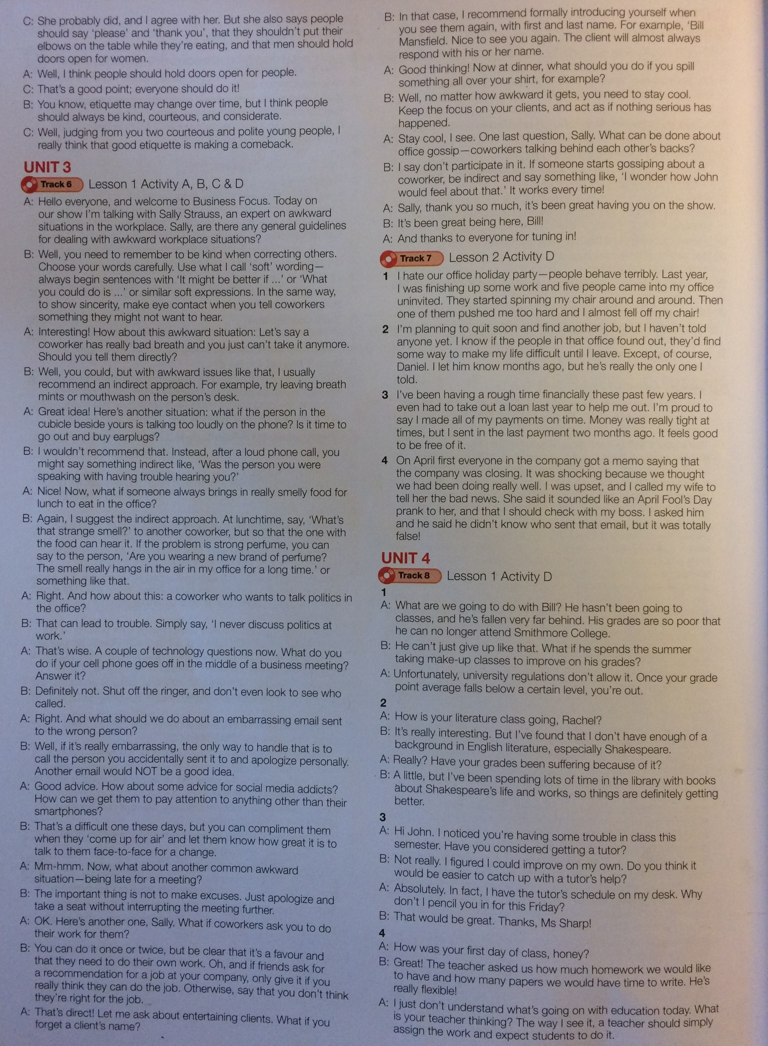

Appendix 2: Reading Task Role-Play Sceneries

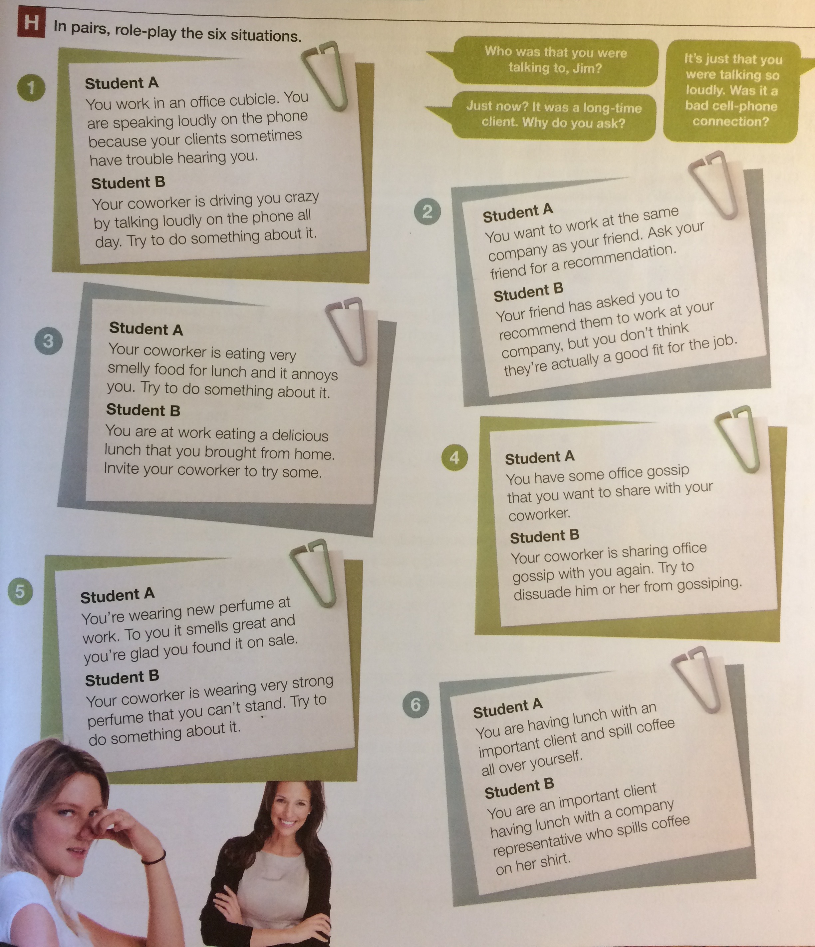

Appendix 3: Reading Task Blog Posts

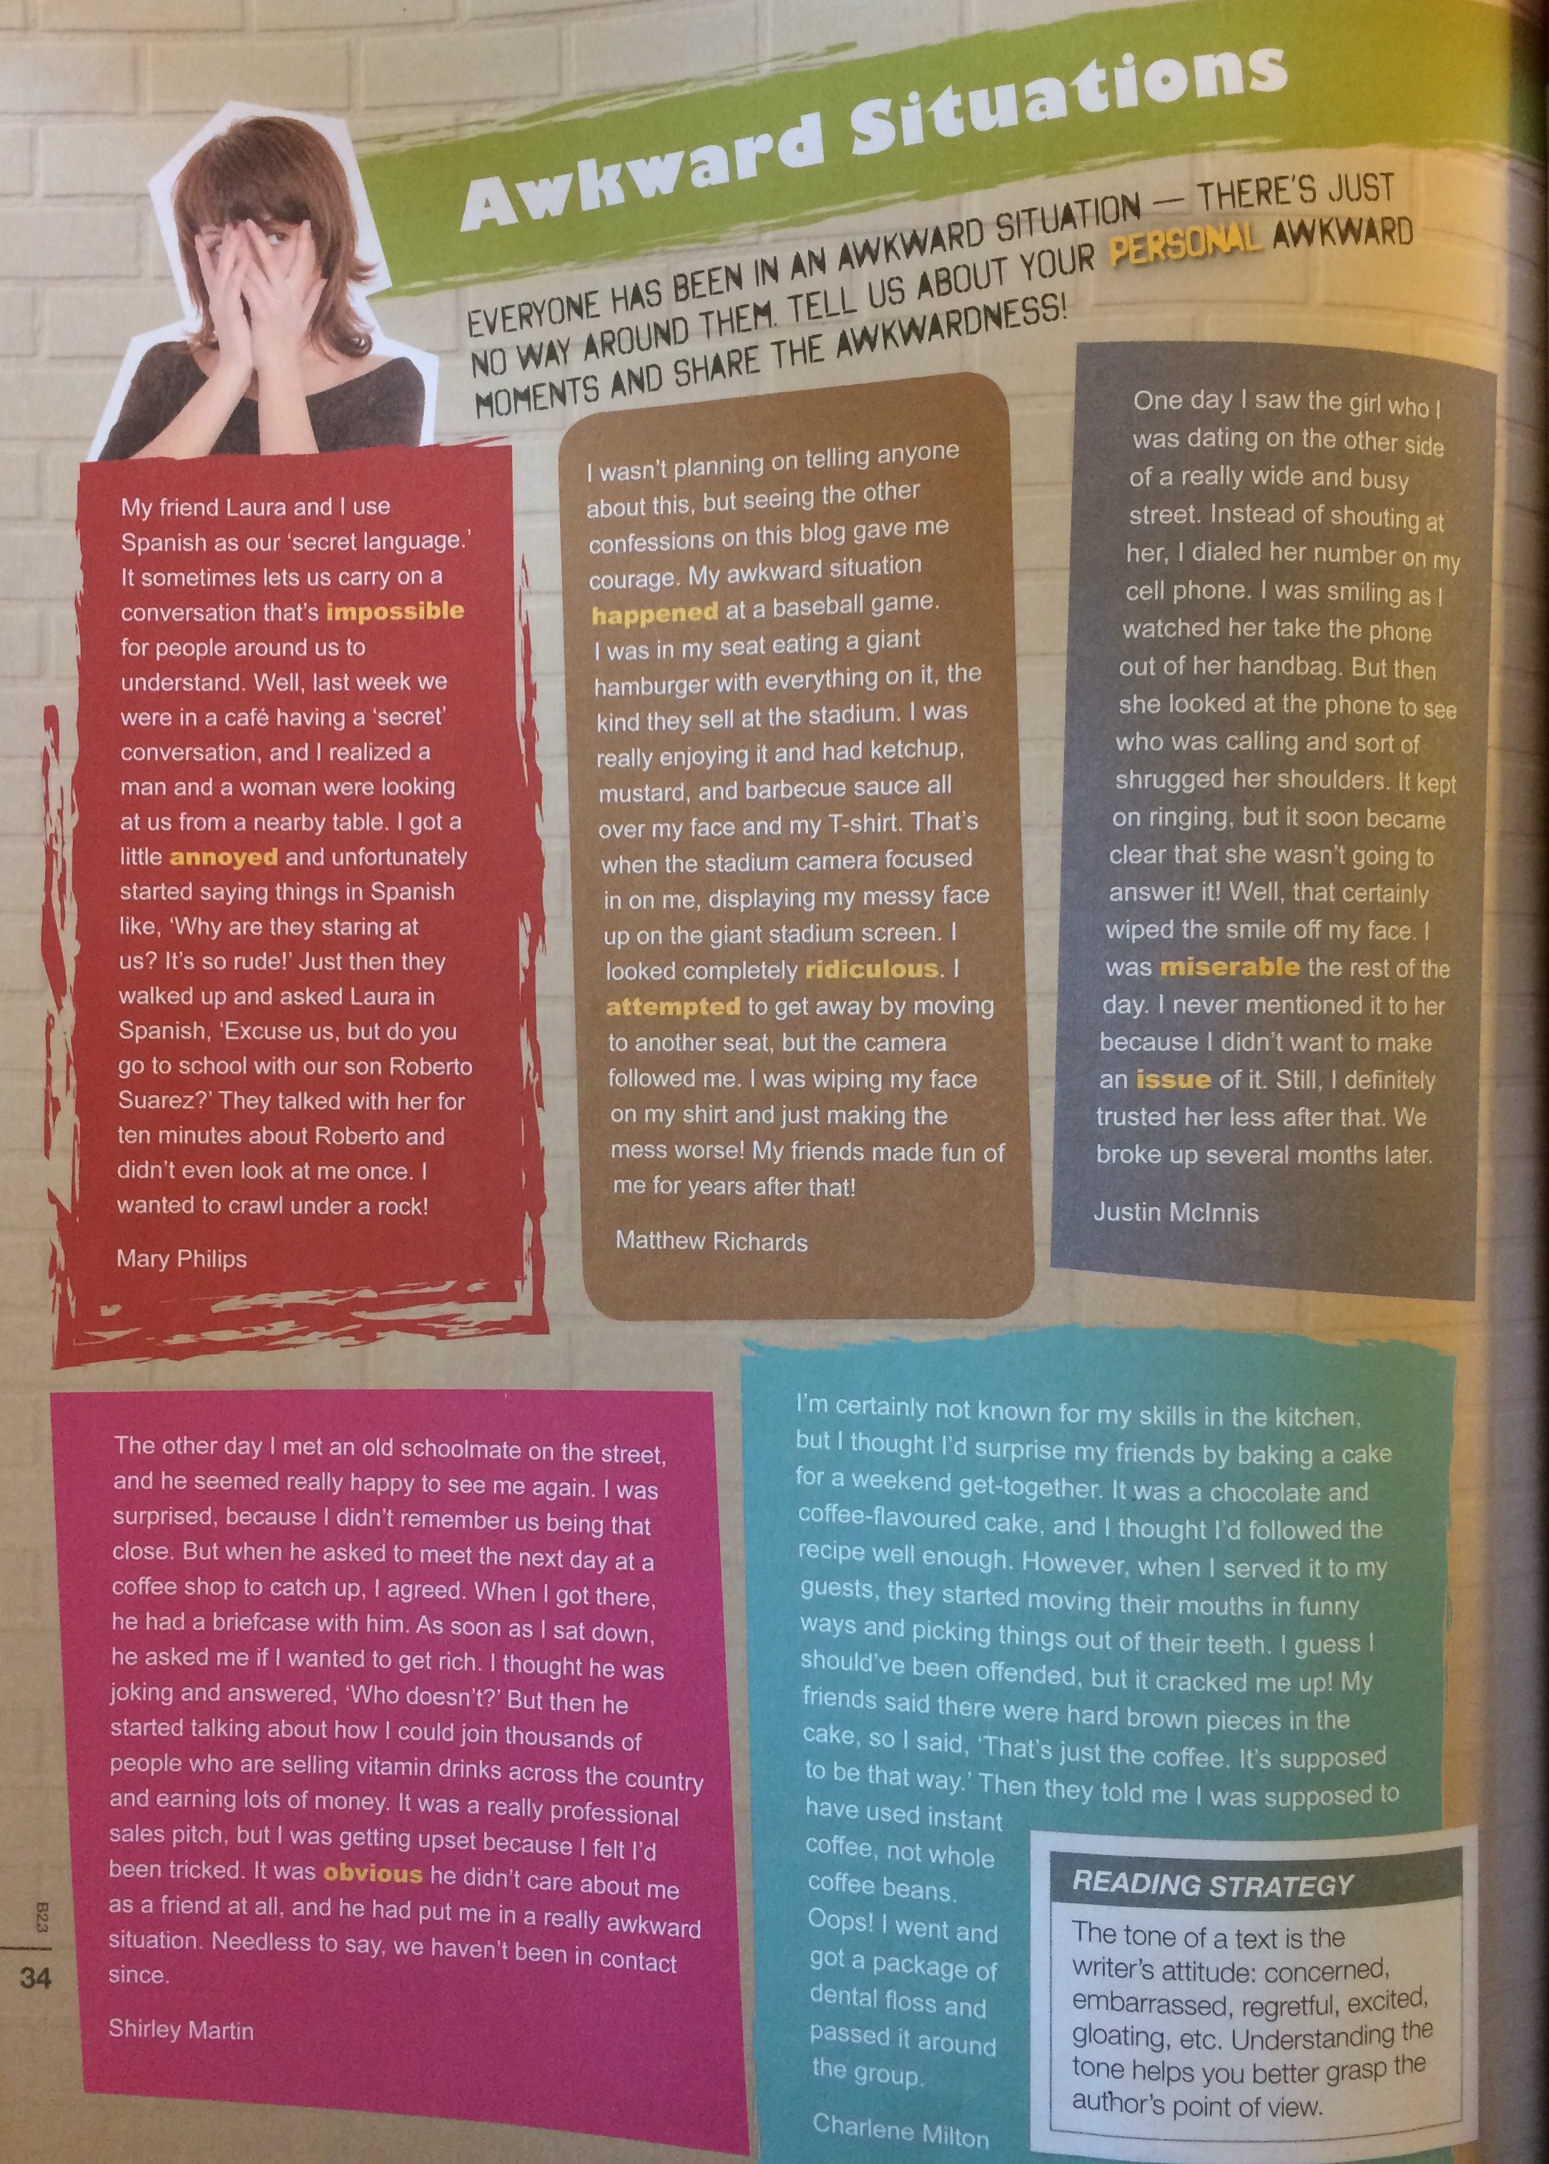

Appendix 4: Reading Task Comprehension Questions

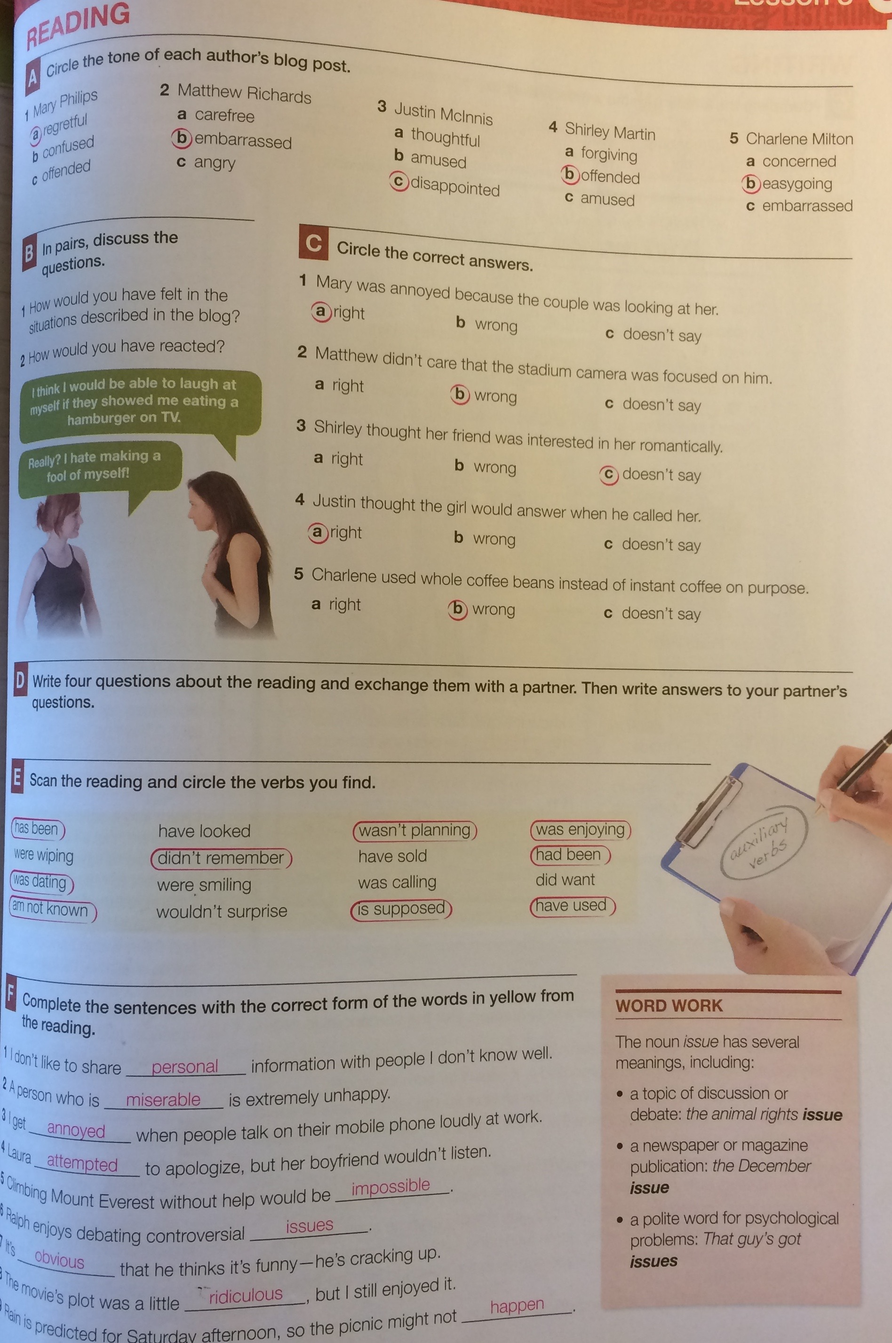

Appendix 5: Vocabulary List

