

GENERAL ENGLISH

Upper Intermediate Level

Spring 2015

Instructor: Emily Meyers

Email: emilymeyers@sandiego.edu

Phone: (203) 240-5528

Class Meetings: MWF 8:25AM – 9:45AM, 9:55AM – 11:15AM

TT 2:25PM – 3:45PM, 3:55PM – 5:15PM

Additional Meeting Times: Mondays 1:00PM – 3:00PM and Wednesdays 1:00PM – 3:00PM

*Syllabus is subject to change*

Class Description

What to Expect. In this level you will continue to develop your English skills over a range of language uses, tenses and vocabulary. Classes will include real-world application of the language and this is truly the time to take hold of the language and make it your own! Challenge yourself regularly. Use your teacher as a resource to help you polish your skills. What do you want to accomplish within the next six weeks? Keep your language goals at the forefront of your mind! You can reach them if you put in the time and effort.

What I Expect. In this class participation is not only expected but it is required. Respect toward your peers and teacher is a necessity. The class is designed to do many pair work and group work activities. Cooperation and patience are important throughout this. Remember that your teacher is not your sole source of information. Your peers can (and will) teach you a lot. You will also help your classmates tremendously. However, you cannot do this from the warmth of your bed! Come to class regularly and remember to eat breakfast!
Breakfast is the most important meal of the day. Seriously. ☺

Classroom Policies

- English only in the classroom unless otherwise prompted. At this stage in your English language learning translating should not be relied upon. Instead, utilize your peers, teacher, and materials. You have wonderful, amazing brains that work in English – use them!
- No eating or drinking in the classroom.
- Students must be on time for class, if you are 10 minutes late or more, you will be marked absent. If you are late more three times in one week it will be counted as absence.

Materials
(You Must Bring These to Class Everyday)

- Student book: General English: Upper Intermediate Level
- Workbook: General English Guide: Upper Intermediate Level
- Handouts from previous classes
- Folder
- Lined paper/Notebook
Grading

- Pen/Pencil

Grading Scale | Total Points
A | 90-100
B | 80-90
C | 70-80
D | 60-70
F | 59 >

Homework | 15%
Projects and Presentations | 20%
Quizzes and Tests | 15%
Participation and Attendance | 50%

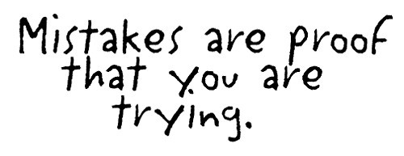

Course Overview

Course Topics | Content  (Integrated Skills Development and Practice)
Unit 1:  Corporate Culture   | - Read about corporate culture  - Listen to a CEO talk about changing a corporate culture  - Discuss negative corporate culture  - Write about how to reinvent a corporate culture  - Task: Create a brochure describing a corporate culture
Unit 2:  Manners & Etiquette   | - Read about Netiquette  - Write an anecdote about a time someone was rude to you  - Listen to people discussing changing rules of etiquette  - Discuss appropriate behavior in different situations  - Task: Create an e-newsletter informing employees of etiquette policies
Unit 3:  Awkward Situations   | - Read different blog posts about awkward situations  - Write a blog post about an awkward situation  - Listen to an expert on how to handle awkward situations  - Task: Create an online forum where people share awkward situations
Course Topics  Continued | Context (Integrated Skills and Practice)  Continued
Unit 4:  World English  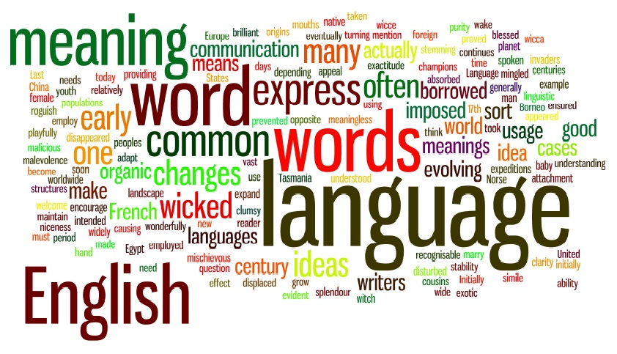 | - Listen to a lecture about learning English for the corporate world  - Discuss technology equipment used in English language classrooms  - Read about global English proficiency  - Write a letter requesting a curriculum change  - Task: Conduct a survey on your classmates’ reasons for learning English
Unit 5:  Leadership   | - Read an article about great leaders in history  - Write an article review  - Listen to a radio interview with a business leadership expert  - Discuss leadership qualities  - Task: Interview classmates for a General Manager position
Unit 6:  Politics   | - Listen to a radio seminar about becoming the President  - Discuss resources for running a political campaign  - Read an article about political lobbying  - Write an argumentative essay  - Task: Conduct a class debate between US presidential candidates

Written Assignments

All written assignments turned in for my review will be assessed using the following ISOT method:

- The appropriateness and originality of the ideas (I) presented
- The level of support (S)—in the form of reasoning and/or evidence—for the paper’s thesis/focus
- The clarity of the paper’s organization (O)
- The technical (T) correctness of the mechanics including proper grammar, punctuation and spelling.

ISOT Area | Needs Improvement | Good | Excellent
Ideas (30%) | The focus and/or the main ideas are unclear, underdeveloped, and/or too simple for class level. | The focus and/or the main ideas demonstrate on-topic, critical, independent thought, appropriate for the class level. | The focus and/or the main ideas demonstrate a deep level of critical analysis, are on topic, and demonstrate independent, original thought.
Support (30%) | Support is illogical, underdeveloped, and/or too simple for class level, and/or not clearly connected to the paper’s focus. | Support is clear, on-topic, and logical, but needs some further development and/or critical analysis. | Support is clear, concisely developed, on-topic, connected, and thoughtful. Demonstrates a high-level of critical analysis.
Organization (25%) | The paper has undeveloped or distracting organization. There may be little cohesion amongst the ideas presented. | Strong organization, but there are a few times when ideas/support seem out of place or could be better organized. | Superior organization that is thoughtful, carefully crafted, and meaningful. There is cohesion and the ideas are presented in an order that bolsters the ideas presented.
Technical (15%) | Grammar, word choice, spelling, punctuation, and sentence structure are consistently incorrect or distracting to the reader. | A few careless errors in grammar, spelling, word choice, punctuation, sentence structure may be present. There may be an instance where errors take away from the author’s intended meaning. | The paper is nearly flawless in presentation. There are no distracting errors at the word or sentence level that take away from the author’s intended meaning.


Class Schedule
Day by Day

Class | Date | In Class | Out of Class
1/2  WEEK 1 | 03/30  Monday | Listening P. 8  Vocab Focus P. 8  Discussion P. 8  Group Work P. 9  Role Play P. 9 | Research: The corporate culture of a major company (ex. Starbucks). Write down 5 things to share.
3/4 | 03/31  Tuesday | Discussion P. 5  Vocab Focus P. 6  Discussion P. 6  Interview P. 6  Grammar Focus P. 7 | Complete: P. 7  Exercise H
5/6 | 04/01  Wednesday | Vocab Focus P. 10  Preposition Focus P. 10  Interview P. 10  Grammar Focus P. 11  Discussion P. 11 | Write: 9 sentences containing one new vocabulary word each from P. 10
7/8 | 04/02  Thursday | Reading P.12  Vocab Focus P.12  Discussion P.13  Reading Comp P.13  Vocab Focus P.13 | Interview: A person outside of our class who is currently employed. Ask 5 questions. Record their answers to share.
9/10 | 04/03  Friday | Vocab Focus P. 14  Writing P. 14  Discussion P. 15  Task Completion P. 15  Presentation P. 15 | Find: A company brochure online that you think has been created particularly well. Bring in.
11/12  WEEK 2 | 04/06  Monday | Vocab Review  Grammar Review  Written Reflection  Discussion Recap  *Unit 1 Quiz | Research: The manners and etiquette of your country (ex. covering your mouth when you yawn). Write down 5 things to share.
13/14 | 04/07  Tuesday | Discussion P. 17  Reading P. 18  Vocab Focus P. 18  Reading Comp P. 19  Grammar Focus P. 19 | Complete: P. 19  Exercise F
15/16 | 04/08  Wednesday | Writing P. 20  Correct Writing P. 21  Vocab Focus P. 21  Listening P. 21  Discussion P. 21 | Write: 5-10 useful expressions you know in English like “rule of thumb” or “as a courtesy”. Bring in.
17/18 | 04/09  Thursday | Grammar Focus P. 22  Writing P. 22  Discussion P. 22  Listening P. 23  Discussion P. 23 | Interview: A person outside of our class about the manners from their country. Ask 5 questions. Record their answers to share.
19/20 | 04/10  Friday | Group Work P. 24  Writing P. 24  Discussion P. 24  Vocab Focus P. 25  Grammar Focus P. 25 | Find: A company with complete different manners than your country. Write down 5 things to share.
21/22  WEEK 3 | 04/13  Monday | Grammar Focus P. 26  Writing P. 26  Task Completion P. 27  Presentation P. 29  Written Reflection  *Unit 2 Quiz | Research: What does “awkward” mean? Find an example of an awkward situation. Bring in.
23/24 | 04/14  Tuesday | Discussion P. 27  Listening P. 28  Vocab Focus P. 28  Group Work P. 29  Role Play P. 29 | Complete: P. 30  Exercise D
25/26 | 04/15  Wednesday | Vocab Focus P. 32  Interview P. 32  Listening P. 32  Grammar Focus P. 33  Discussion P. 33 | Write: 9 sentences containing one new vocabulary word each from P. 32
27/28 | 04/16  Thursday | Reading P. 34  Vocab Focus P. 34  Discussion P. 35  Reading Comp P. 35  Grammar Focus P. 35 | Interview: A person outside of our class about an awkward situation they have been a part of or seen. Record their answers to share.
29/30 | 04/17  Friday | Writing P. 36  Vocab Focus P. 36  Vocab Focus P. 37  Interview P. 37  Discussion P. 37 | Find: An awkward moment on a TV show or in a movie. Be able to summarize in class.
31/32  WEEK 4 | 04/20  Monday | Grammar Focus P. 38  Role Play P. 38  Task Completion P. 39  Presentation P. 39  Written Reflection  *Unit 3 Quiz | Research: How do countries around the world use English? Pick one country to use as an example. Write down 5 things to share.
33/34 | 04/21  Tuesday | Discussion P. 41  Vocab Focus P. 42  Interview P. 42  Listening P. 42  Grammar Focus P. 43 | Complete: P. 43  Exercise H
35/36 | 04/22  Wednesday | Listening P. 44  Discussion P. 44  Group Work P. 45  Discussion P. 45  Writing P. 45 | Write: 5 ways you would improve our classrooms at EF if you could. What forms of technology would you implement?
37/38 | 04/23  Thursday | Vocab Focus P. 46  Interview P. 46  Grammar Focus P. 47  Prep Focus P. 48  Discussion P. 48 | Interview: A person outside of our class whose native language is not English. Ask 5 questions and record their answers to share.
39/40 | 04/24  Friday | Reading P. 48  Vocab Focus P. 48  Discussion P. 49  Vocab Focus P. 49  Writing P. 49 | Find: Out the difference between ESL, EFL, and ESOL. Are there any other acronyms that are similar? Bring in.
41/42  WEEK 5 | 04/27  Monday | Writing P. 50  Vocab Focus P. 50  Task Completion P. 51  Presentation P. 52  Written Reflection  *Unit 4 Quiz | Research: What qualities do successful leaders possess? Write down 5 things to share.
43/44 | 04/28  Tuesday | Discussion P. 53  Reading P. 54  Vocab Focus P. 54  Reading Comp P. 55  Vocab Focus P. 55 | Complete: P. 55  Exercise F
45/46 | 04/29  Wednesday | Writing P. 56  Vocab Focus P. 56  Vocab Focus P. 57  Listening P. 57  Interview P. 57 | Write: 9 sentences containing one new vocabulary word for each from P. 57
47/48 | 04/30  Thursday | Grammar Focus P. 5  8Interview P. 58  Listening P. 59  Discussion P. 59  Vocab Focus P. 59 | Interview: A person outside our class about one person who they view to be a great leader. Ask 5 questions and record their answers to share.
49/50 | 05/01  Friday | Group Work P. 60  Interview P. 60  Vocab Focus P. 61  Interview P. 61  Role Play P. 61 | Find: A person who you consider to be a strong leader. Be able to discuss in class.
51/52  WEEK 6 | 05/04  Monday | Grammar Focus P. 62  Discussion P. 62  Task Completion P. 63  Presentation P. 64  Written Reflection  *Unit 5 Quiz | Research: What are the main political parties in the US? Write down 5 things to share.
53/54 | 05/05  Tuesday | Discussion P. 65  Listening P. 66  Vocab Focus P. 66  Group Work P. 67  Discussion P. 67 | Complete: P. 66  Exercise G
55/56 | 05/06  Wednesday | Vocab Focus P. 68  Listening P. 68  Interview P. 68  Grammar Focus P. 69  Vocab Focus P. 69 | Write: A short paragraph including an overview of the political situation in your country. Bring in.
57/58 | 05/07  Thursday | Reading P. 70  Vocab Focus P. 70  Discussion P. 71  Vocab Focus P. 71  Writing P. 71 | Interview: A person outside our class about their view of American politics. Ask 5 questions and record their answers to share.
59/60 | 05/08  Friday | Grammar P. 74  Task Completion P. 75  Presentation P. 76 | Have a wonderful weekend! I will miss you all! Good luck!

